Press Release
FOR IMMEDIATE RELEASE

Summit County Invites Community Partners to Bring Family Law Clinics Directly to Local Neighborhoods

Court Celebrates it’s fourth year running Family Law Clinic; Continues to build access to Justice

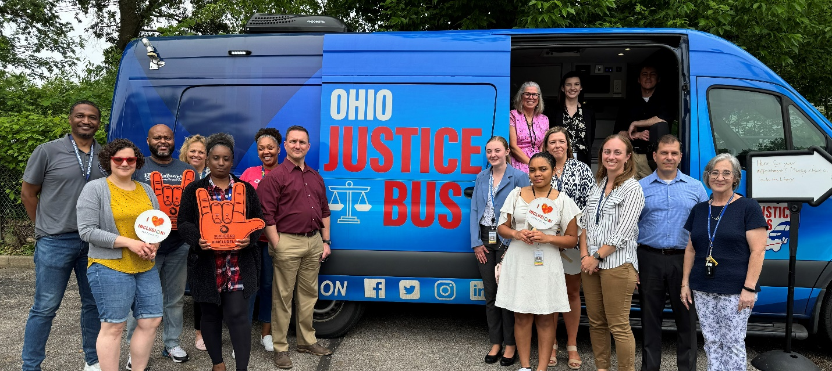

Tuesday, February 10, 2026 - Akron, Ohio — Following a highly successful 2025 year of community-based Family Law Clinics, the Summit County Domestic Relations Court is inviting organizations across Summit County to partner in this years round of outreach. Community groups are encouraged to invite Administrative Judge Katarina Cook to speak at their venue, or to host the Ohio Justice Bus on site, to bring free family law resources directly to the people they serve.

In 2025 alone, participation in these clinics grew by more than 50 percent, contributing to a three-year increase of over 70 percent in residents served. This growth reflects not just rising demand, but a proven model that works: meeting families where they are, reducing barriers to access, and creating meaningful connections between the court and the community without adding resources.

Through Judge Cook’s leadership, the Court has partnered with the Ohio Justice Bus, local community organizations, and the Summit County Family Law Bar to deliver legal help outside the courthouse. Clinics are hosted in familiar, trusted neighborhood spaces such as libraries, community centers, and nonprofit facilities eliminating transportation challenges and saving residents time and expense.

Check out the 2025 recap video here: https://drcourt.org/wp/ojb2025/

At each Family Law Clinic, residents meet with local attorneys who provide free legal information and guidance. Community partners—including nonprofits and social-service providers are present to connect families with housing, healthcare, and financial stability resources. In certain circumstances, the model allows for same-day hearings with Judge Cook, reducing delays and easing the stress caused by prolonged waiting periods.

How the Community Can Get Involved
The Court is actively seeking community partners to help continue this momentum:
- Host a Clinic: Organizations with space for approximately 30–40 people can host a Family Law Clinic at their location.
- Invite the Conversation: Groups without space are encouraged to invite Judge Cook to speak about access to justice, community trust, and innovative court outreach.
- Support the Work: Attorneys willing to donate just two hours of pro bono time are essential to the success of each clinic.
- Expand the Impact: Service-oriented organizations are invited to pair clinics with additional resources—housing, health, education, or financial services.

By working together, Summit County continues to move justice out of the courthouse and into the community—where it can make the greatest impact.

Media Contact and To host, partner, or learn more, contact:
Paul M. Henry
Mediator, NCPM | Public Information Officer
Summit County Domestic Relations Court
205 S. High Street, Akron, OH 44308
(330) 364-7845 | phenry@drcourt.org

